# Yarn Storage Ideas

One of the clear ways of storing your yarns is to keep them in a space where there is a penetration of sunlight and a normal airflow is ensured. Other than that if it is stored in a stiff place there is a high chance of bugs to start a home.

## Yarn storage ideas

This might seem to a lot that what is the necessity to find a proper way of saving yarns, but depending on the storage management the quality of the yarn is highly affected. The following measurements will keep your yarns fresh as new and fluffy.

* Plastic bags to store yarns are not a wise choice, thus the yarns can’t breathe. As per observations, yarns can hold up to 30% of the weights in normal moisture. Else they can get molded and the prior quality is questioned.

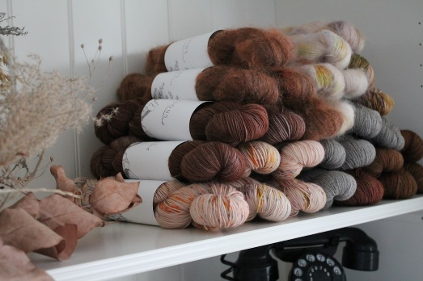

No plastic bags, breathable yarns

* Damp places and areas are highly discouraged for storing purposes.
* You can select plastic containers like box and store them in a closet, where it is safe from direct sunlight

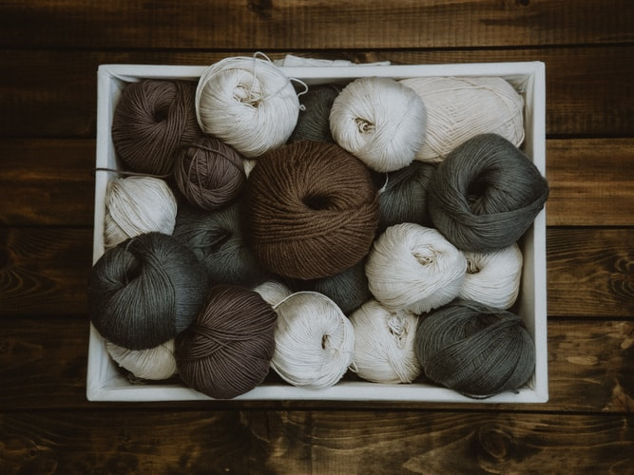

Box-like container, safe from direct sun-light

* Baskets made of bamboos and storing on them in an open space might hook the beetles to reside in and make the yarns wear off.

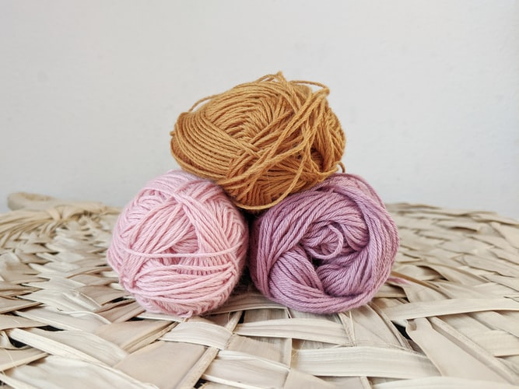

Bamboo-like materials to be avoided for storing

* A linen closet is a perfect place for the yarns to be stored

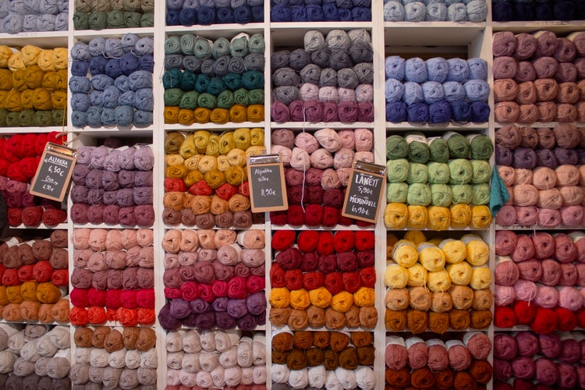

Linen closet for storing yarn

* Make sure the garment is not unlaundered
* Dark places are favorites for bugs and beetles, so if you are keeping your stores in a dark damp place for a long time make sure you relocate them.
* Mothballs can help you get rid of such disturbance.

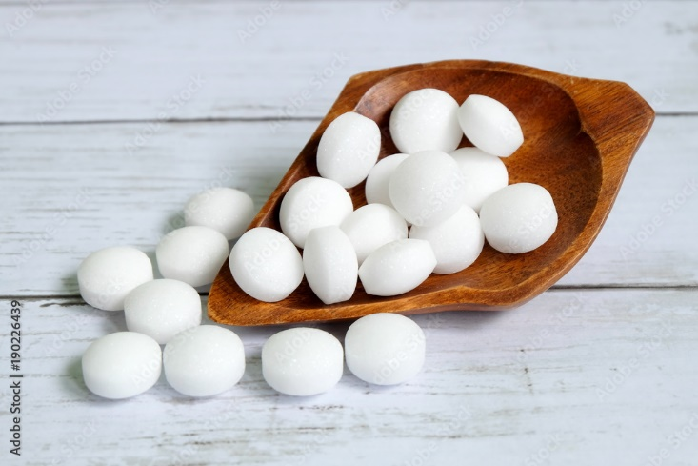

Mothballs to help you

* Also, you might go for natural remedies that can prevent the bugs, beetles to stay away from your yarns.

The following blog thread will give a bit explicit ideology that is described in the previous section <https://www.crochet-world.com/blog/?p=9172>

## Best possible ways to preserve the yarns

All the bounded rules for storing the yarns might seem tough. But in reality, it’s just simple as ever. Locate a place that has the normal environmental state, no excessive heat or, moisture, just a daily living room.

The very next fact is to select an exclusive cupboard or wooden haul, that has free movement of air and room temperature and keeps the yarns stacked. A wise way is to keep the storage visual transparent so, if there is any up and down inside, you can easily figure the rest out. There are some cool ways of demonstrating the storage.





You can get more ideas to store your yarns from the following thread and the representations are from <https://www.thesprucecrafts.com/yarn-storage-ideas-4176280>

## Selection of shelves for yarn storage

Best suited shelves would be your daily cupboard and wooden ones. This is highly suggested to not keep anything around that specific shelve that might affect the stored yards. You can stack the yarns in plastic or any kind of boxes and then décor the shelve as per choice.

## FAQ

How to store the yarns untangled?

If you’re planning to store a yarn that is a save from use, you better cut off the open strings, else just keep it separate from the rest yarns.

How to get rid of bugs?

Use Mothballs, to prevent any kind of bug attack. The mothball fragrance might stink you, in that case, keep the mothball at a moderate distance from the touch of yarns. This will keep the yarns safe and fragrant-free.

Do the colors stay safe?’

Yes, the pigments remain as it was if there is no pressure of heat and moisture. Sunlight keeps a bad remark on the color of the yarns.

Do the yarns swallow by time?

No there is such differences but if you do not check the humidity, or keep it in a place that has more moisture the yarns might get molded and disturbed.

## Conclusion

If your yarn stays intact as it was in the first place you can be assured that the quality remains pure. This is very important in the case of the quality assurance that the yarns are stored perfectly. Else you can meet losses very often.